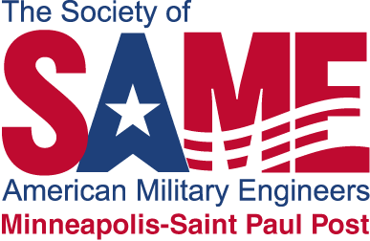

**Society of American Military Engineers (SAME)**

**Educational Grant for Math and Science Grades K-12**

The Society of American Military Engineers (SAME) is offering educational grants for up to $3,000.00 for elementary and secondary schools for the upcoming 2024-2025 school year for schools within a 100-mile radius of Saint Paul, Minnesota. One fundamental goal of SAME is… *To promote an understanding of, and appreciation for, the engineering related disciplines and to help the young people in our communities be better prepared to become our future engineers…* The Minneapolis - St Paul Chapter of SAME is requesting applications from schools and classroom teachers who are committed in supporting the math and sciences that support future engineering-related career opportunities. We are encouraging all grade levels to participate.

Applications for these grants will be reviewed on the following criteria:

* Creativity and quality of proposed project
* Demonstrated demand or need for the project
* Support of the Minnesota or Wisconsin math and/or science academic standards

Applications are due April 26, 2024.

Elementary and secondary teachers / schools that are promoting the math and sciences within the 100-mile radius of Saint Paul, Minnesota are encouraged to apply.

The application forms are posted on the SAME website. For application forms and a listing of the historical grants awarded go to:

[Minneapolis-St. Paul Post Grants for Educators - SAME](https://www.same.org/minneapolis/stem/grants/)