Date of Submission: 4/30/2023

Submitting Community / Communities of Interest (COIs):
Energy and Sustainability COI (E&S COI)

Point of Contact: Norm Campbell, Siemens E&S COI Chair

Topic Title: Addressing the Electric Vehicle Infrastructure Challenge (EVIC)

Pressing Issue Description – What is the issue or problem: Describe the Pressing Issue to include the problem statement:
With the rapid adoption of electric vehicles in the federal fleet and the current mandates via EO, there is a massive disconnect between the available electric infrastructure to deliver the requires kilo-watts to properly charge and manage the fleets. Each agency is approaching the identification of the distribution system limitations in a unique manner. This will lead to inefficient scope and deployment which will increase overall cost to the government and confusion to industry in solving the overall challenge.
Proposed Project Scope: Specifically what part or parts of the problem or issue would this project address and not address:
This project will address the consistency of analysis, evaluation and scope development to develop straight forward and cost effective means to address the electric and distribution system challenges to deploy large numbers of EV’s for federal customers.

Potential Impact: What is the impact if the issue or problem is solved; what does “Right” look like:
- Energy and Sustainability education, awareness, and best practices related to evaluating Electric Vehicle (EV) deployment, facility readiness assessment, gap analysis, best practices on electric distribution expansion and enhancement, electric system upgrade and deployment implementation, government vs POV charging, future system planning. This effort advocates electric infrastructure education, awareness, and best practices related to increased demand and use based on the implementation of EVs throughout the government.
- The EnSusCOI proposes to lead several events and discussions as part of an IGE initiative on EVIC and focus attention on community and infrastructure impacts from:
    - Evaluation of current distribution systems for available growth
    - Identifying vehicle and charging needs based on type of EV, use, etc.
    - Understanding increased electric consumption of EVs and impact to overall base/facility.
    - Understanding the gap between current and future need of distribution with deployment of EVs
    - Understanding the supply chain impact EV deployment and electric infrastructure including charging systems, transformers, panels, and such.
    - Addressing the government and POV charging dynamics
    - Engaging utility partners to maximize implementation and long-term solutions.

Projected Outcome(s): What documents produced and their purpose (white papers, etc.), processes, policy, etc. requiring modification or revision, other:
- Potential Outcomes include:
  - Consistent scope development with utility, industry and government needs addressed
  - White papers and presentations outlining collaborative processes
  - Developing a process to help a Post and local federal client implement the IGE process and documenting the results.

Involved Organizations: Which organizations within Industry, Government, Academia, other SAME Communities of Interest (COIs), etc. should be a part of a project team to address this problem or issue:
In support of this IGE initiative, the EnSusCOI leadership team has and will continue to reach out to the following organizations to engage them with for this effort:
- DoD
- DoE
- DHS
- GSA
- USACE
- SAME National
- FAME COI
- SAME POST(S) – TBD

Click or tap here to enter text.

Timeframe for Resolution: Approximation of when this problem should be solved to remain relevant:
  - Draft IGE reviewed and approved within E&S COI – 30 days
  - National Approval – 60 days
  - Webinar topics and schedule through JETC 2024 – 30 days
  - Other schedules and data to be developed include:
    - Team member role identification
    - Government POC
    - Existing available information on EVIC
    - Industry POCs strategy, policy, technology and implementation
    - Other items as determined by the team.
    - As an example, the below exhibit shows a brief issue that will be facing facility and site managers.
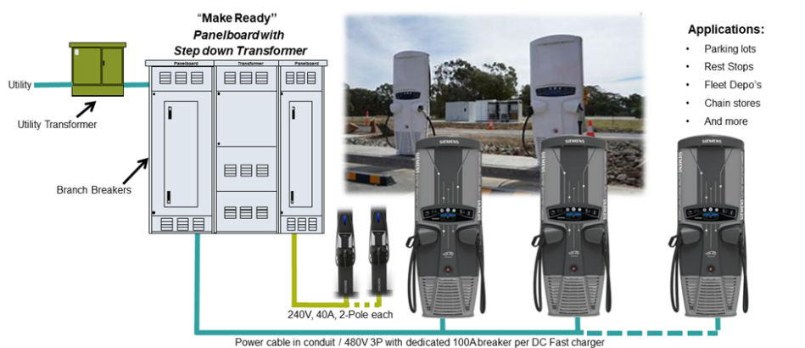
Members of your Organization or Subject Matter Experts (SMEs) available to participate in a project team:
Team members include:
- Matt McCann, AECOM
- Michelle Exaros, Fulcrum Energy
- John Constantinide, Space Force
- Ray Arguelo, Power Engineers
- Jamere Bates, Black and Veatch
- Doug Mackenzie, JLL
Issue Development to Date: Attach any white papers, minutes of workshops, etc., having relevance to this Pressing Issue (if applicable):
  - As this is a new IGE, no focused programs from EnSusCOI are available; however, several JETC and SBC presentations started this discussion and those presentations will be the initial lead.
  - Additional information will be provided and used to further refine this focus area upon approval of the IGE by National.
  - Outreach to government EV SME’s will allow for quick addition of existing resources to speed implementation

Click or tap here to enter text.

