SAME Resilience and Architectural Practice COI’s Industry Government Engagement (IGE) Initiative:
Planning for Federal Facility Innovation

The challenge. Aligning federal facility planning efficiently with rapidly evolving resilience and mission requirements

Trend Convergence and the rapid pace of change are creating opportunities to redefine the role of federal installations

- The world is entering a data and analytics generation. Data is emerging as the strategic currency and is changing the security and sanctuary of military and federal installations as we have know them.
- Severe weather is increasing and creating vulnerabilities for many installations. Some vulnerabilities will impact military operations in yet to be understood ways.
- The DoD and Federal Agencies are moving into a new “wave” of advanced technology in most if not all its traditional and emerging missions, with new requirements in facilities for mission assurance, environmental resilience, cybersecurity, enhanced telecommunications, and digital architectures to enable artificial intelligence, machine learning and advanced manufacturing.
- Major advances in new weapon systems are on the deployment horizon and will reshape requirements for optimal and efficient support provided by both legacy and new basing concepts.

The first signs of rapid and in some cases radical change to the status quo lead to surprise and early technical obsolescence. The research, development, and manufacturing base as well as the defense installations must rethink their programs, policies, and procedures to provide effective and efficient platforms for training, operations, and industrial support.
Consider the impact of artificial intelligence on OSINT today. Consider the impact of hypersonic flight and low observables of yesterday. Consider the installation dependence on its community-based housing, power, water, and waste. Consider the impacts of satellites and global unmanned vehicles over the past 20 years. Were we ready or did we scramble?

History and many noted authors like John P Kotter in Leading Change argue that in a globalized, ever-evolving environment, successful organizations are those that can implement long-term change. This initiative is about defining what that long term change looks like for the installation planning functions across the defense establishment.

Mission Statement:
Determine the policies and best practices for the services/agencies to proactively enhance future federal facility planning to meet long-term mission requirements and weapon system changes.

Proposed Organization/Process: The IGE will be guided by an Integration Team, composed of a representative from each service, industry representatives, and SAME Community of Interest (COI) members. This committee sets the direction for the IGE, defines the operational perspective, and guides the workgroups (Resilience, Technology, Efficiency/Infrastructure, and Workforce) with Integration Team members heading the workgroups. Work group members come from SAME COIs, Posts, and partner professional organizations.

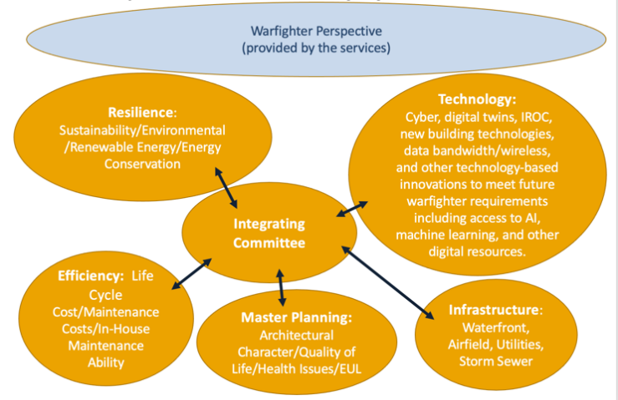
Integration Team:
- Proposed Service Representatives:
- Army Representative – Edmond Gauvreau, FAIA, MSAME, Base Master Planning Work Group and Randy Covington, HQ USACE
- Navy/Marine Representative – Brandon Tobias and Tracy Addis, NAVFAC
- Air Force – Andrew Scott, HQ AF and Amy VandeVeer, Air Force Civil Engineer Center
- Coast Guard – CAPT David Obermeier, PE, FSAME
- Veterans Administration, State Department, or General Services Administration Representatives
- Industry and COI Representatives:
- John Mogge, Jr. PhD, AIA, REM, FSAME, Colonel USAF (ret), Resilience Work Group
- Get Moy, PhD, PE, LEED AP, PMP, Resilience Work Group
- Lucian Niemeyer, Technology Work Group
- Chris Geiger, Director of Sustainability, Audit and Planning, Lockheed Martin
- Paula Loomis, PhD, FAIA, FSAME, AICP, LEED AP, Colonel USAFR (ret), Efficiency/Life-Cycle Work Group
- Cathy Otis AIA and Patrick Hogeboom, PE, Colonel Army (ret), COI chairs

Intended Outcome:
- White papers defining how to functionally address trend convergence and proposed updates to federal facility planning guidance based on assessments of emerging threats, trends, capabilities, and industry best practices.
- Cross functional integration of players and stakeholders in actionable doctrinal, policy and procedural changes to consider.
- Introduction of new technologies, best practices, and access to industry experts for federal facility planners to enhance programs for resilience, operational requirements, and workforce.

Questions for EAG:
- Please confirm your service representatives
- Please provide any additional outcomes/questions answered that would benefit your service

